**Daily Scrum or Standup Meeting**

Team name: Group 8_________________________

Scrum Master: Cole_______________________

Date: 4-12_______________________________

|  |  |  |  |
| --- | --- | --- | --- |
| **Team Member** | **What did you do since the last scrum?** | **What do you plan to do before the next scrum?** | **What obstacles do you have?** |
| Cole | Finished most of lot admin, still missing a couple things and a few bugs to squash | Work on the bugs | Time |
| Austin | Finally got authentication working | Finish final polish on customer interface | Time |
| Jeremy | Worked on APIs, finishing up the last little bits | Continue working on APIs | Time |
| Logan | N/A | N/A | Time |
|  |  |  |  |

# Burndown

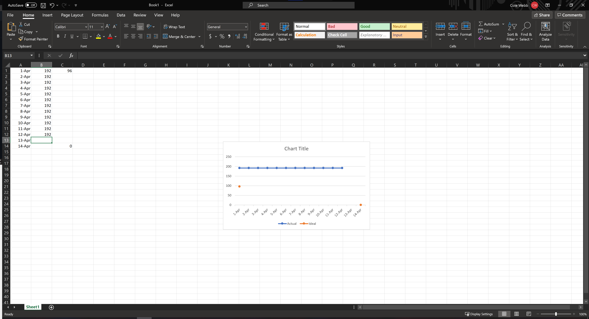

# Screenshot of you project board

